**Math 8CP NAME _____________________**

**May 28- 31 Final Review for EOCE**

**Tuesday:**

**1.** Classify each number as Rational (R) or Irrational (I):  **, , ,** 1.3,

2. Write a linear equation in slope-intercept form

|  |  |  |  |  |  |
| --- | --- | --- | --- | --- | --- |
| Input, *x* | 0 | 1 | 2 | 3 | 4 |
| Output, *y* | 7 | 4 | 1 | -2 | -5 |

for the table**.**

**#3-5 Solve the equations:**

**3.**  –7x + 8 = 71 **4.**   **5.**  

6. Graph 



**7.** Which line is the graph of y = 4x - 1?

A B C D

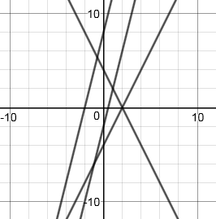

**Wednesday:**

**1.** Write an equation and solve: **2.** Solve the system:

“19 decreased by four times a number is 17” y = 2x + 5 and 2y – 2x = 8

**#3-6.** **Simplify:**

**3. **    **4. $\frac{18x^{10}}{3x^{9}}$**  **5.**     **6.**  

**7.** What is thevalue of x that would make this equation true? $\frac{m^{24}}{m^{x}}=m^{9}$

**Thursday:**

**1.** Find the equation of these lines:

a. Slope is  and goes through point (4, -3) b. Goes through (1, -5) and (-2, 1)

**2.** Write the number using scientific notation.

**a.**  0.000008037 **b.**  580,000

**3.** Write each number in standard form.

**a.**   **b.**  

**4.** Multiply and express your answer in scientific notation. (1.7 x 10-5)(5.5 x 103)

**5.** Divide and express your answer in scientific notation. (2.7 x 1012) ÷ (3 x 103)

**6.** Write the number 25 using exponents. **7.** Write the number 8 using exponents.

**8.** Find the cube root of 64.

**Friday:**

**1.** Find the measure of the missing **2.** The triangles are similar.

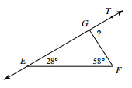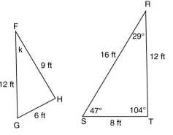 exterior angle( ). Find the value of angle k and side ST.

3. A cone and its dimensions are shown below. What is the volume of the cone? Leave your answer in terms of π.

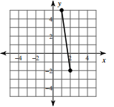 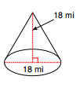

4. a. Find the distance between the points in the coordinate grid.

b. Find the slope of the line.