**1.)** Simplify each expression by **combining like terms**. Use the tiles to help you!

**a.** (2*x*2 + 4*x* + 1) + (*x*2 + 2*x* – 5) **b.** (5*x*2 + 9*x* – 6) – (2*x*2 – 2*x* + 5)

**2.)**  Jeanne thinks that *x* + *x* is the same as *x*2. Is this true?_____ Justify your answer using

x = 5. _________________________________________________________________

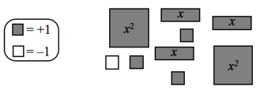

**3.)**  Write an algebraic expression representing the collection of algebra tiles at the right.

*yyy*

*x*

1

1

1

1

**4.)** Add what is missing to make these statements true as an ***algebraic expression***. The key at right may help you remember which tiles are which.

**a.**

+

=



=



**b.**

+

=



**c.**

**5.)**  When Jackie had created her comparison mat, she had many ***x*** tiles and the same number of **–*x*** tiles. Her partner Collin said *“So they cancel each other out. Just remove them!”* *“I can’t do that!”* Jackie exclaimed.  *“I don’t know what x is! What if the shaded x’s are one number and the white x’s are another number?”* Jackie asked.

Should Jackie be concerned? Is Collin correct?

____________________________________________________

____________________________________________________

**6.)** Fill in each blank to make the statement true (there are NO y tiles).

