Water Park Project

TASK 1: Design your Park

You have recently been hired to create a blueprint for a water park. Your boss, Gelatinous Harrington, is a very controlling person. She wants you to include specific attractions and necessities in your design. Be prepared to answer her questions before you have had enough time to adequately explain what you are doing. First off, she wants it to be done on a large sheet of graph paper so that she can apply her mathematical knowledge to make the park the best it can be. She has issues and will yell at you if you do not do this properly. To make your blueprint:
- Use a pencil. You can go back and make it colorful when you finish everything else.
- Identify the center of your paper, and use a ruler to draw the x and y axes.
- Plot the approximate entrance points (where the line starts) of each attraction on the graph paper. Some coordinates are given - create your own coordinates for the rest! Try to spread them out as much as possible.
- Complete the handout, front and back.
- Draw each attraction near or around its entrance in a creative fashion.
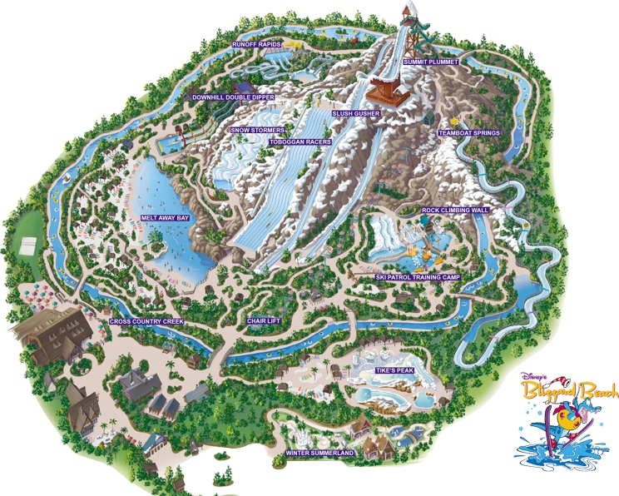
Items to be included on the design:
*Help center
*Large whirlpool
*3 different water slides
*Toddler area
-Entrance
-Lazy river
-Concessions
-Gift shop
-Restrooms
-Security desk

WATER PARK PROJECT NAME____________________________

TASK 1: Graph and Name Coordinates

Location: | Ordered Pairs: | Location: | Ordered Pairs:
Help Center | (-13 , 13) | Entrance | (________ , ________)
Large Whirlpool | (-19, 4) | Lazy River | (________ , ________)
Water Slide #1 | (-9, 0) | Concessions | (________ , ________)
Water Slide #2 | (-15 , -10) | Gift Shop | (________ , ________)
Water Slide #3 | (13 ,-12) | Restrooms | (________ , ________)
Toddler Area | (15, 11) | Security Desk | (________ , ________)

TASK 2: Calculate each Slope
After identifying each attraction’s location with ordered pairs, you are now ready to calculate the slope between attractions using the slope triangle, or
Using a colored pencil and a ruler, MARK the direct path to/from the locations mentioned below. Calculate the simplified slope of the line that is formed, and show your work in the space provided.

Help Center to Water Slide #1 | Toddler Area to Help Center | Water Slide #1 to Water Slide #2
Toddler Area to Large Whirlpool | Lazy River to Gift Shop | Security Desk to Concessions
TASK 3: Calculate each Distance
A team of surveyors is trying to determine how large a space they will need to design your park. You have been asked to determine how far away certain attractions are from one another. This will provide them with the information they need to expand the park from your scaled blueprint to actual dimensions. Calculate the distance by applying using the points and Pythagorean Theorem. Show your work in the space!

Help Center to Water Slide #1 | Toddler Area to Help Center | Water Slide #1 to Water Slide #2
Toddler Area to Large Whirlpool | Lazy River to Gift Shop | Security Desk to Concessions

TASK 4: Find the equation of the line through 2 attractions
The surveyors want to know what line some of the attractions lie on, so they need you to use the slope of the line containing these attractions and one of the points to find the y-intercept. Show your work in the space provided. Be sure to write the final equation in slope-intercept form.

Help Center to Water Slide #1 | Toddler Area to Help Center | Water Slide #1 to Water Slide #2

